**Programming Project 2 – The Birthday Attack**

Karxyriah Ashley and Chance Currie

The Task

The task is to run a program that runs the “birthday attack” against a hash function that is defined as “BadHash44.” This hash is a short hash function that is constructed through SHA256. BadHash44 will only take the first 44 bits of the output that is given by SHA256, and our main objective is to find two arbitrary inputs of the function BadHash44 which result in the same output. In other words, we need to find a “collision”, which is the same hash being used for two different inputs, in the BadHash44 function. We also need to write the random message inputs and corresponding hash values into a text / .csv file and it needs to be sorted based on hash values.

The Program

Our code was written in Python. The program begins with importing a few important Python libraries: hashlib, random, and operator. For hashlib, we import this to utilize a built-in implementation of SHA256. For random, this library will be used for generating random messages that will have their hash values compared for collisions. For operator, it gives us a wider variety of operations that will be implemented in this program.

Next is the previously mentioned BadHash44 function. It takes in a plaintext message, encodes the message, then creates a SHA256 hash of the encoded message through the implementation of the hashlib library, and the function will return only the first 44 bits of the output that is generated from the SHA256 hash.

We then have the find_collision function, which is where the meat of our program is. First, we define variable n to be the length of a SHA256 hash, which, given by its name, is 256 bits, so we set n to be 256. We then open a file called hash.csv (this is a file that is and already should be created on our machine for this program to work, but no information is currently contained within it) with the intention to write to the specified file. We then define variable x0 to be a randomly generated number in bits with the size of n, where n is 256. Then, we convert x0 from bits into a hexadecimal value, and we want to get everything from index position 2 to the end of the newly converted hexadecimal string value. While the length of x0, being the hexadecimal string in this case, is not equal to 64, we want to add the number 0 to the front of x0 in string form. We then set variable “x” to be the value of x0, and then set variable “x_prime” to be the value of x. We then make a hash_dict variable that will act as a dictionary to store hash data.

The variable “i” will be our variable that will update as we go through our while loop, and it’s initialized with a value of 0 to begin with. Our while loop that follows the initialization of i is as follows: while the variable i is less than 2 to the power of n/2, we run the BadHash44 function with the message being x. Once the BadHash44 function has finished running, we set its return value to be the current value of x. With the x_prime variable, it’s the same idea, but the BadHash44 function is ran twice, so it would look like: BadHash44(BadHash44(x_prime)), and this is set to the current value of x_prime. We then need to compare and see if x is equal to x_prime. If they are the same, then we break the while loop, otherwise we increment the value of i by 1 and run the while loop again.

For each iteration of the while loop that is ran, we want to write information to the file that we opened earlier. To start, we set x_prime equal to x, and set x equal to x0. Then, we have a for loop that will run for j in the range of i. With each pass through the loop, we want to write the value of x and its corresponding BadHash44 has value, as well as x_prime and its corresponding BadHash44 hash value. To start the for loop, we begin by setting the x and x_prime values in the hash dictionary variable to be equal to their BadHash44 counterparts. If the BadHash44 hash values of x and x_prime are equal, we want to print out those hashes respectively. We then want to sort the hash data by making a new_dict variable to act as a new dictionary, where we sort the hash_dict based on the items contained within it and set the sorted new_dict variable to itself. We then want to write these hashes to the file, and we do this by going into a for loop where we loop through all the new_dict items and write each key and value pair inside of the new_dict variable. Once this has been completed, we can then close the file and we can then return x and x_prime. If they are not the same, we want to make x equal the BadHash44 hash value of x, and make x_prime equal to the BadHash44 hash value of x_prime. If we find that none of the BadHash44 hash values equal one another, we return None, indicating that no matches were found.

At the bottom, we want to test the function, and we do this by calling the find_collision function on x and x_prime. If x returns None, the we print out a statement saying that no collision was found. However, if there is a returned collision, we print out a statement saying that a collision was found, and we print those values respectively.

Program Demonstration Through Screenshots

Using the nano editor inside of Kali Linux, we create a file called hash.csv, and currently, there is nothing inside of it. This file is also located within the same directory as the main.py program.

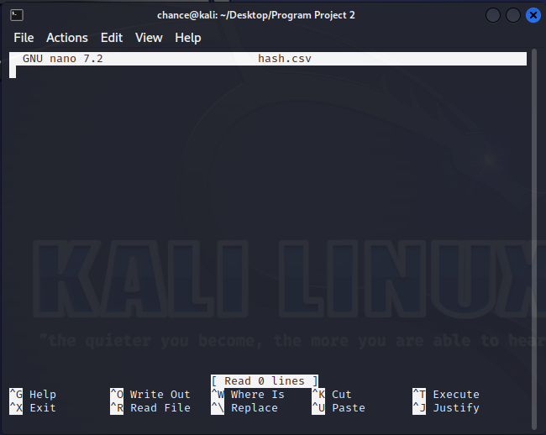

Here, we are running the program. There won’t be any output for a little bit, probably no more than a minute depending on your hardware, as the program is working behind the scenes to find any collisions.

Here, we have found that there is indeed a collision. We can see that the hashes of x and x_prime are the same, despite the numbers of x and x_prime bring the same.

Upon completion of the program, if we now open the hash.csv file, we can now see that the file has been populated with data. The screenshot only shows the beginning portion of the data.

